FORNAX™ ePlanCheck Rule
Rule Information
Rule ID | WTR 6.4.4
Rule Name | Underground Layout Pipe Cover Requirement
Chapter | Part 2 Distribution
Section | 2.4 Services
Handbook | Code of Practice for Water Services  Incorporating Amendment No. 1 and No. 2 – CP 48 : 2005

Rule Description
    - Piping laid underground outside buildings should have a depth of not less than 500 mm of cover measured from top of the pipe to the finished surface of the ground to prevent damage to the pipes.

Rule Interpretation
- This rule checks for the minimum depth required for pipes laid underground outside building.
- The minimum depth shall be measured from the top of the pipe to the ground level.
- The minimum depth should not be less than 500mm.

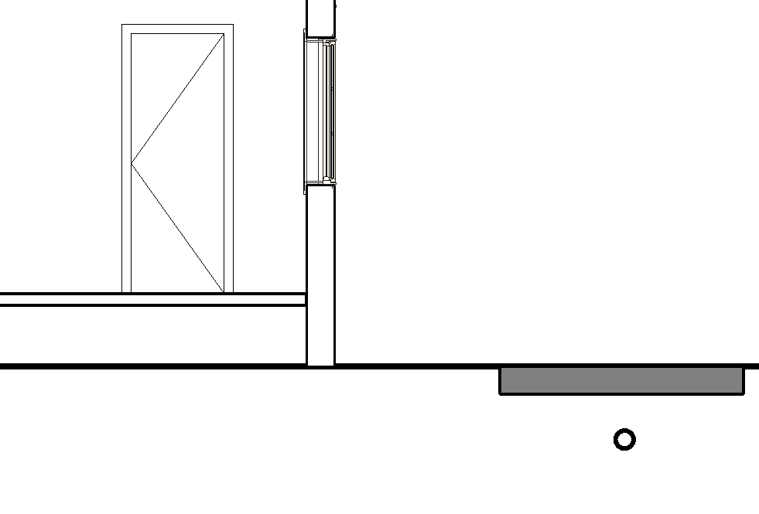
Pipe Top Cover

Top of ground

Min. 500mm

FIGURE 01
Section View

Rule Scenario

Scenario 01 – Compliant 01
Requirement | Minimum cover for external layout pipes is equal to 500mm  - Minimum cover shall be measured from top of the pipe to the finished slab surface
Description | Pipe cover depth is equal to 500mm
SECTION

Pipe Top Cover

Top of ground

Depth = 500mm

FIGURE SCENARIO

Scenario 01 – Non Compliant 01
Requirement | Minimum cover for external layout pipes is equal to 500mm  - Minimum cover shall be measured from top of the pipe to the finished slab surface
Description | Pipe cover depth is equal to 450mm
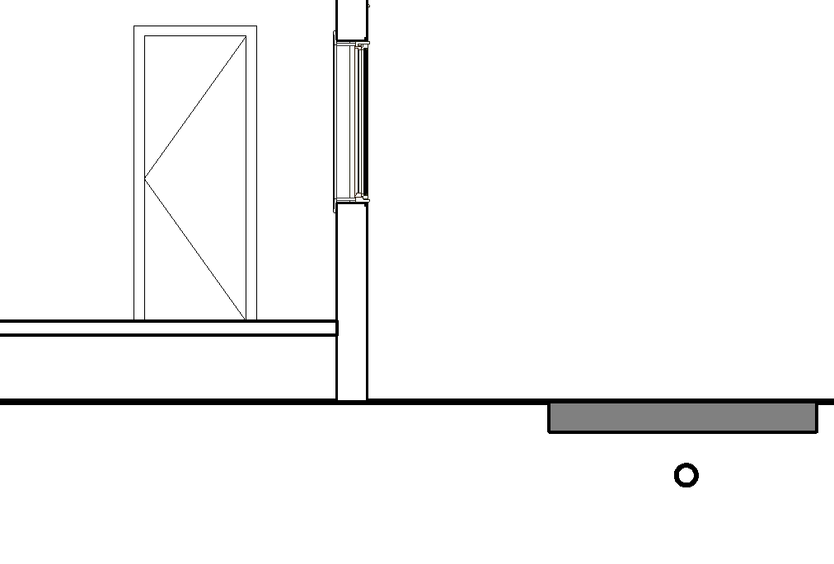
Pipe Top Cover

Top of ground

Depth = 450mm

SECTION

FIGURE SCENARIO

Request For Information
- We believe the correct clause number should be WTR 2.4.4
- What is meant by finished surface?

Rule Parameters

System Type
Cold Water |  | 
Hot Water
 | Sanitary
 | Sewerage
Vent

Element Type 1
State | Type | Property | Operator | Value
Include | IfcFlowSegment | IfcDescription | Contains | External Pipe
Include | IfcSlab | IfcDescription
Include | IfcSite | IfcDescription
Exclude |  | Any | Match | <User define>
 |  |  | N.A. | N.A.

Element Type 1 Condition
Element Type 1 Depth |  | ≥ | 500 | mm

Result Messages
- 8.3.3 Provision of Check Valve and Vacuum Breaker for Hand Held Bidet Spray
- Non-compliant (TotalResultNumeric)
- BuildingStorey (TotalResultPerFloorNumeric)
  - Distance of top of ElementType1Name to ground level is below 500mm.

- Compliant (TotalResultNumeric)
- BuildingStorey (TotalResultPerFloorNumeric)
  - Distance of top of ElementType1Name to ground level is greater than 500mm.

Sample Result Model Views
- 6.4.4 Underground Layout Pipe Cover Requirement
  - Non-compliant (1)
    - Non-Compliant, distance of top of pipe to ground level is below 500mm
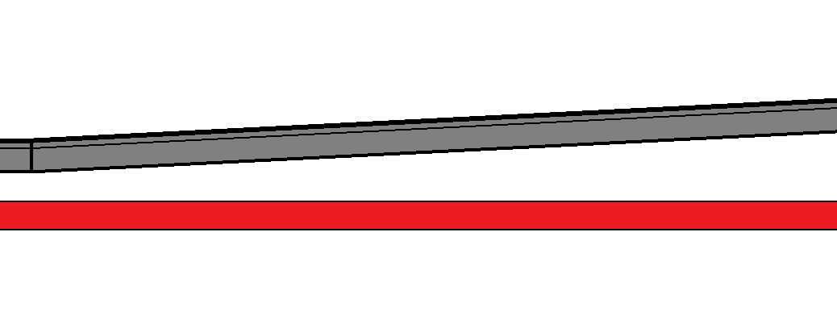
Pipe

450 ≤ Depth ≤ 750mm

Top of ground

Depth = 500mm

Depth = 800mm

  - Compliant (1)
    - Distance of top of pipe to ground level is greater than 500mm
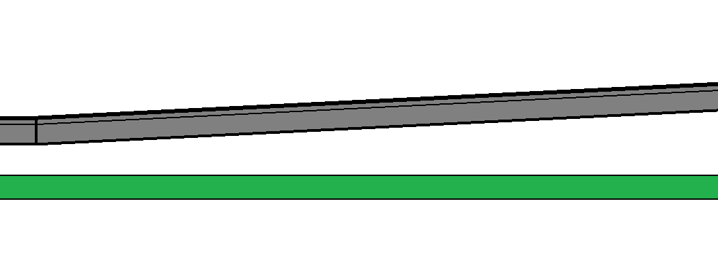
500 ≤ Depth ≤ 800mm

Pipe

Top of ground

Depth = 500mm

Depth = 800mm

Testing Scenario Notes

Modelling Guideline

Specification Log
RA | Karl Bautista
Last edit date | 28 September 2018
ePC version
Updates | Updated UAT model (Revit)

